# **Scope & Namespaces**

## Object

#### **In general, anything that can be assigned to a variable in Python is referred to as an object.**

#### **Strings, Integers, Floats, Lists, Functions, Modules etc. are all objects.**

#### 

## Identity of an Object

#### **Whenever an object is created in Python, it will be given a unique identifier (id).This unique id can be different for each time you run the program.**

#### 

#### **Every object that you use in a Python Program will be stored in Computer Memory**

#### **The unique id will be related to the location where the object is stored in the Computer Memory.**

## Name of an Object

#### **Name or Identifier is simply a name given to an object.**

#### 

## Namespaces

#### **A namespace is a collection of currently defined names along with information about the object that the name references.**

#### **It ensures that names are unique and won’t lead to any conflict.**

#### 

#### **Namespaces allow us to have the same name referring to different things in different namespaces.**

#### 

#### **Code**

def greet_1():

a = "Hello"

print(a)

print(id(a))

def greet_2():

a = "Hey"

print(a)

print(id(a))

print("Namespace - 1")

greet_1()

print("Namespace - 2")

greet_2()

#### **Output**

Namespace - 1

Hello

140639382368176

Namespace - 2

Hey

140639382570608

## Types of namespaces

As Python executes a program, it creates namespaces as necessary and forgets them when they are no longer needed.

Different namespaces are:

1. Built-in
2. Global
3. Local

### Built-in Namespace

Created when we start executing a Python program and exists as long as the program is running.

This is the reason that built-in functions like **id(), print()** etc. are always available to us from any part of the program.

### Global Namespace

This namespace includes all names defined directly in a module (outside of all functions).

It is created when the module is loaded, and it lasts until the program ends.

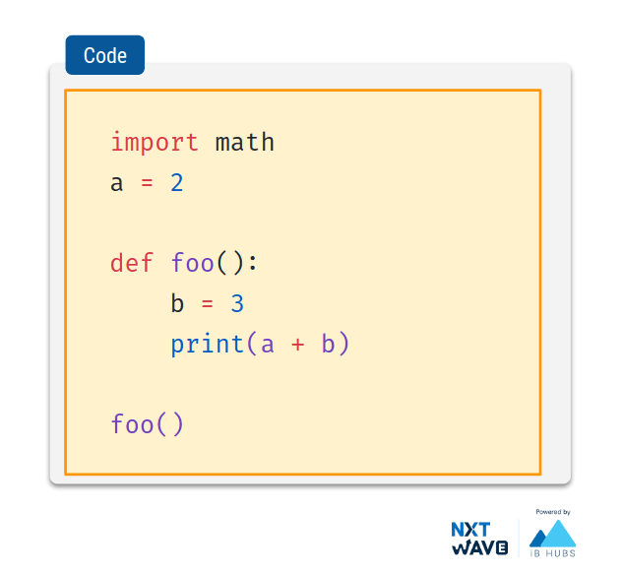

### Local Namespace

Modules can have various

functions and classes.

A new local namespace is created when a function is called, which lasts until the function returns.

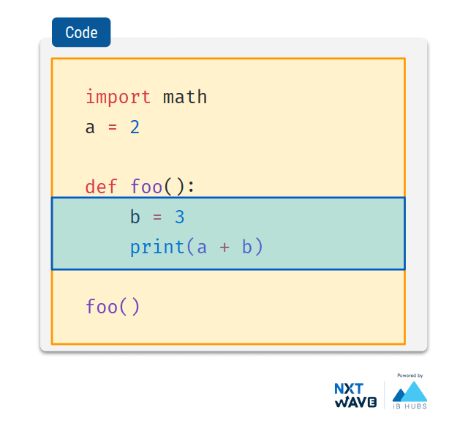

## Scope of a Name

The scope of a name is the region of a program in which that name has meaning.

Python searches for a name from the inside out, looking in the

local, global, and finally the built-in namespaces. 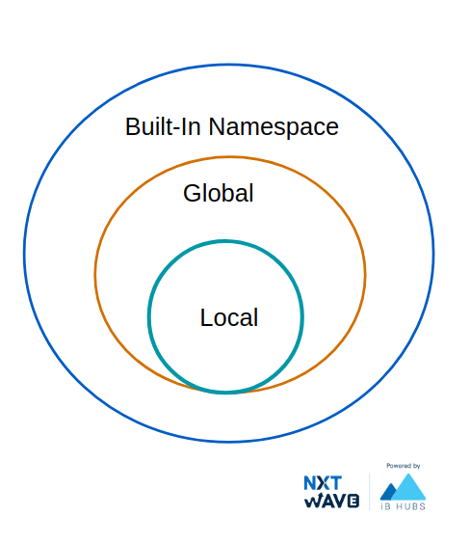

### Global variables

In Python, a variable defined outside of all functions is known as a **global variable**.

This variable name will be part of **Global Namespace**.

### Local Variables

In Python, a variable defined inside a function is a local variable.

This variable name will be part of the Local Namespace which will be created when the function is called and lasts until the function returns.

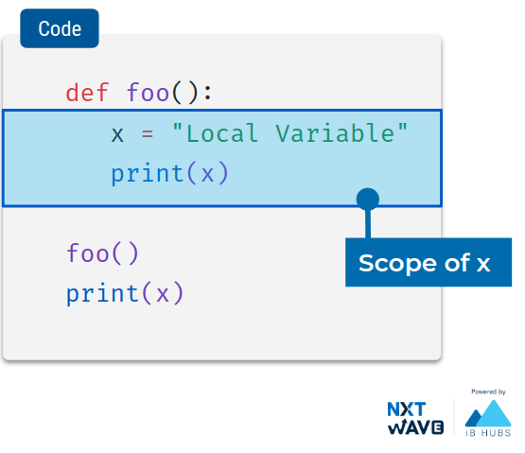

#### **Code**

def foo():

x = "Local Variable"

print(x)

foo()

print(x)

#### **Output**

Local Variable

NameError: name 'x' is not def

As,

x is not declared before assignment, python throws an error.**As,x is not declared before assignment, python throws an error.**

### Local Import

#### **Code**

def foo():

import math

print(math.pi)

foo()

print(math.pi)

#### **Output**

3.141592653589793

NameError: name 'math' is not d

### Local Variables & Global Variables

x = "Global Variable"

def foo():

x = "Local Variable"

print(x)

print(x)

foo()

print(x)

#### **Output**

Global Variable

Local Variable

Global Variable

Modifying Global Variables

global keyword is used to define a name to refer to the value in Global Namespace.

**Code:**

x = "Global Variable"

def foo():

global x

x = "Global Change"

print(x)

print(x)

foo()

print(x)

**Output:**

Global Variable

Global Change

Global Change